Halloween dance

SPOOKTACULAR DANCE.

MONDAY, OCTOBER 31ST, 2016

TICKETS WILL BE $3.00 (INCLUDES SNACKS)

CASH OR CHECKS

***MAKE CHECKS OUT TO BRIDGEPREP ACADEMY INTERAMERICAN***

Student’s Name: ________________________

Homeroom Teacher: ______________________

Grade:_________

[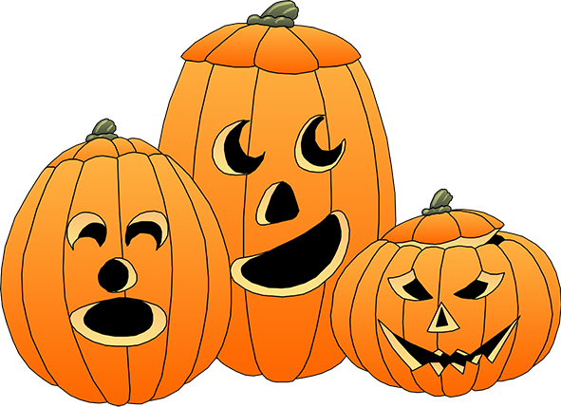](http://www.google.com/url?sa=i&rct=j&q=&esrc=s&frm=1&source=images&cd=&cad=rja&uact=8&ved=0CAcQjRxqFQoTCKHPoPCYncgCFULXHgodjHMF3Q&url=http://holidaysimages.com/halloween-clip-art-cute-pumpkin-very-happy.html&bvm=bv.103627116,d.dmo&psig=AFQjCNH0rVjkwplQ7k7SmTRjej7DcdCrQA&ust=1443648744989666)